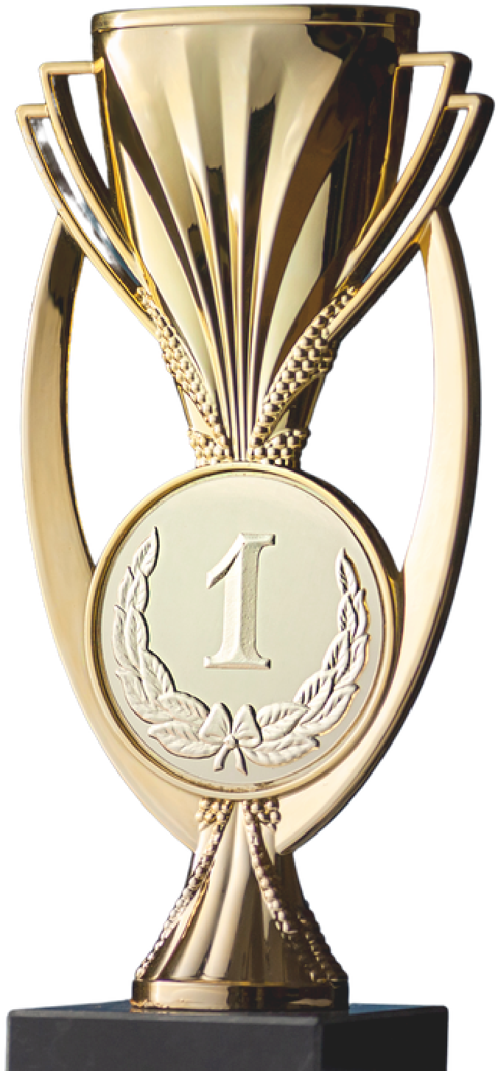



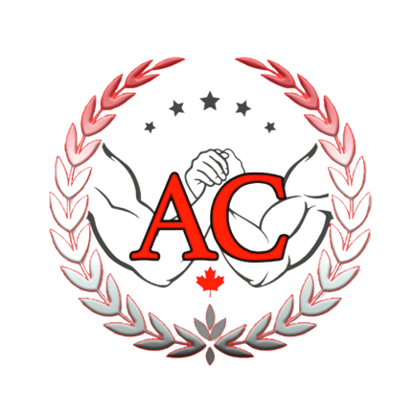
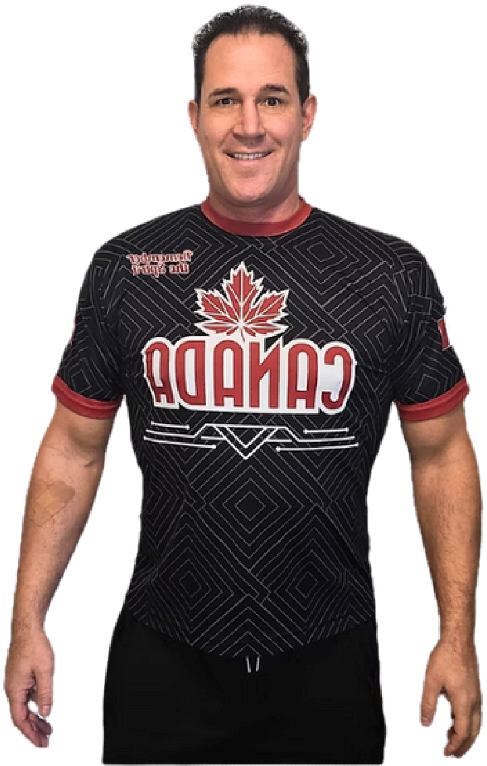


ARMWRESTLING
CHAMPIONS
WWW.CLAYTONFAULCONER.COM
W
R
I
T
T
E
N

B
Y

C
L
A
Y
T
O
N

F
A
U
L
C
O
N
E
R
THE JOURNEY, THE
TRAINING, THE MINDSET
Table of Contents
- Introduction – why armwrestling is more than a sport
- The foundation – why train and what you gain
- Developing a well-balanced training routine
- How to prepare for a tournament
- Synchronization
- The psychology of winning
- Becoming a multi-dimensional armwrestler
- Armwrestling in Canada and the USA – two different systems
- Like a cat with 9 lives
- Grip Strength – A hidden key to power and health
- Good sportsmanship and team spirit – the soul of the sport
- Staying lean, fit, and focused
- The importance of sleep and recovery
- Knowing when to rest and when to push forward
- The Top 6 secrets to winning every armwrestling match
- Conclusion
- About the Author
- About the Producer

Introduction – why armwrestling is more than a sport

Armwrestling has always been more than two people testing their strength at a table. To those who truly understand it, this sport represents resilience, focus, and the will to overcome anything life throws your way. Whether you’re a seasoned competitor or someone discovering this sport for the first time, armwrestling is a gateway to becoming stronger, not just physically, but mentally and emotionally.
When I first wrapped my hand around another competitor’s, I wasn’t thinking about winning a medal or a trophy—I was thinking about challenge. Challenge against myself. Challenge against limitation. Challenge against fear. And through that challenge, I found clarity, purpose, and a lifelong community.
The beauty of armwrestling lies in its simplicity. You don’t need a gym full of equipment or a team of professionals. You need a table, an opponent, and the will to improve. Yet within that simplicity lies endless complexity: the angles of leverage, the timing of the start, the rules and referees, the psychology before a match, and the balance between power and precision. Arm wrestling has taken me across Canada, into the United States, and to stages where the best in the world come to compete.
The true lessons I’ve learned weren’t about winning gold—they were about building character, discipline, and compassion for others who share the same passion.
Over my 30+ years of involvement in this sport, I’ve seen it all—injuries, comebacks, triumphs, losses, and countless friendships. I’ve also learned that the lessons from armwrestling extend far beyond the table. They apply to your health, your relationships, and the way you face life’s challenges.
When people ask me why I continue to armwrestle after so many years, the answer is simple: because it keeps me young. Physically, mentally, and emotionally. The sport gives me a reason to train, to connect, and to stay grounded in a world that moves faster every year.

As you read this eBook, you’ll not only discover ways to win an armwrestling match, but you will also learn quickly and easily what it took me over 30 years to learn.
You will uncover a philosophy of strength built on patience, respect, and love for the game. I hope that this eBook serves as your guide and motivation to pursue greatness, one match at a time.

The foundation – why train and what you gain
Every athlete starts with a reason. Some train to win, others to stay fit, and a few because they simply love the process of getting better. My reason? All of the above—and then some.
When I first began arm wrestling, I wasn’t naturally gifted. I lost more matches than I won. I remember going home sore, sometimes frustrated, but never defeated. Each loss became a lesson, each match a reminder that improvement only comes through consistent effort and humility.
I trained because I wanted to feel stronger—not just physically, but mentally. Armwrestling isn’t only about who has the biggest biceps or strongest grip; it’s about understanding your body, your timing, and your opponent’s movement. It teaches you to think under pressure, to adapt when things don’t go as planned, and to stay calm when everyone else loses focus. There’s another layer to training—community. Walk into any arm wrestling club, and you’ll find people from all walks of life: mechanics, students, parents, teachers, and entrepreneurs. What unites them is passion. They gather weekly to train, learn, and share stories. Some are chasing world titles; others just want to feel healthy and connected. The laughter, sweat, and teamwork that fill those rooms are what keep the sport alive.
Beyond the physical benefits—stronger arms, shoulders, forearms, and grip—armwrestling improves cardiovascular health and endurance. It builds resilience and mental clarity. There’s something powerful about standing across from another person and testing yourself. It forces you to be present, to confront self-doubt, and to trust your preparation. I’ve always believed that you don’t need to be the best to fall in love with a sport. You just need to show up and give it your all. Over the years, arm wrestling has given me more than I ever expected: lifelong friends, a reason to travel, a platform to teach, and an outlet for personal growth.
I made this website and started coaching because I want to share those same benefits with you. My approach is open and honest—I don’t hold back techniques or secrets.
Everything I’ve learned over the past three decades is yours to apply. Whether you’re here to become a better competitor or simply improve your health, you’ve come to the right place.
My message is simple: arm wrestling will teach you how to win—but even more importantly, it will teach you how to handle loss with grace, how to persevere through setbacks, and how to transform challenges into opportunities. The body becomes stronger through resistance, and so does the mind.

Developing a well-balanced training routine If you want to become a complete arm wrestler, balance is everything. Balance in technique, training intensity, and rest. I’ve seen people who focus only on strength but neglect technique; others who master form but never develop speed. The key to long-term progress lies in combining all components.

Every arm wrestling training session should include every component you wish to improve:
- Mock starts
- Top rolls
- Hooks
- Side pressure
- Strap practice
Each of these drills targets a different aspect of your game. Mock starts sharpen your reflexes and reaction time. Top rolls and hooks improve control and adaptability. Side pressure builds the raw drive you need at the table, while strap practice prepares you for competition scenarios where slips are inevitable.
It’s essential to understand the order of training. Try to arm wrestle before you weight train.
When you armwrestle, you give 110%—there’s no halfway effort. Arm wrestling before exercising with weights will lower the risk of getting injured. If you arm wrestle after you weight train, your muscles are already tired and there is more rick of an injury.
A balanced arm wrestling practice should focus on four pillars:
- Speed: You need explosive reaction time to gain position quickly.
- Strength: Without consistent resistance training, your endurance fades fast.
- Technique: Knowing when to rotate, when to drag, and how to use leverage separates champions from amateurs.
- Psychology: Staying calm, composed, and confident under pressure wins more matches than brute force ever will.
Your training should reflect these principles. For example, after a day of table practice, spend time analyzing how you can improve — Writing this down and journaling this can help fine-tune your next training session.
Overtraining can set you back. Muscles grow during rest, not during stress. Listen to your body, sleep well, and fuel properly. A great arm wrestler doesn’t just train harder—they train smarter. When Clayton coaches, I often tell my students: don’t train just to win the next match—train to stay able to train for the long term, not the short term.
The sport rewards those who are patient, consistent, and willing to learn. If you can develop a balance in your body and mind, you’ll not only become a better armwrestler— you’ll become a better version of yourself.

How to prepare for a tournament
Preparing for a tournament isn’t just about showing up strong; it’s about showing up ready — physically, mentally, and emotionally. The moments before competition reveal whether your months of dedication, diet, and discipline were balanced correctly. Every tournament, no matter how big or small, is an opportunity to learn, grow, and refine your strategy.
When I first began competing, I made the mistake of treating preparation as just another workout cycle. I’d lift, I’d pull, I’d sweat — and then I would show up to the competition.
Over the years, I realized there’s a science to peak performance. Preparation doesn’t begin a week before the event; it begins the moment you commit to training and competing. From that day forward, everything you do — from your morning walk to the food you eat — becomes part of your tournament plan.
I believe that all of the following components should be improved:

Cardiovascular Conditioning
Many people underestimate the role of having good cardio in arm wrestling. It’s not just a strength sport; it’s an endurance sport. Matches can last from a few seconds to over a minute, and every heartbeat counts. I’ve always trained my lungs and heart to keep up with my body.
I mix walking fast and light jogging in what I call “controlled cardio.” I walk to warm up, then jog until my heart rate enters my fat-burning zone. Once fatigue hits, I walk again — cycling through this for 15 – 30 minutes to start and I increase the time as I get better.
Over time, this combination improved your endurance and also your mental stamina. When you can control your breathing under stress at the table in competition, you gain an edge over your opponent. In the middle of a high-intensity match, calm breathing helps you stay focused on important factors instead of catching your breath.

Weight Management
In competitive arm wrestling, your weight class can be a deciding factor in your success. I always aim to compete in the lowest healthy weight category because people are generally stronger when they are heavier.
To manage my weight, I track the calories I take in and also what I burn on a daily basis.
I don’t follow fad diets that work temporarily. The principles are good, but longevity is more important that losing weight and gaining it back. It is heathier to lose fat over a longer period of time rather than a short time.

There are two ways to lose weight: lose fat or lose water.

To lose water weight:
You can go for a walk, go into a sauna or lay is a hot bathtub. All 3 methods cause the body to warm up and reduce water held. Use the method that your body reacts well to and practice the method you use so that your body is not shocked.

Walking:
This is a great way to lose water weight and burn calories. It gets you out of your house and able to see new things.

Soaking in a hot bathtub:
Fill a bathtub with as much hot water as possible. Lay on your back in the hot water and your body will sweat due to being hot. I go 10 minutes in the hot water and 10 minutes out. I stay in the bathroom where the tub is with the door closed. The bathroom stays warm and your will continue to sweat while out the hot water. I have lost 9 lbs of water using this method in 4 hrs.

Sauna:
If you have access to a sauna, it can be used to lose water weight. Take a small tower with you to absorb the sweat produced. This method generally takes less time than the hot bath tub method.

Weight ins for larger tournaments can be done the day before the competition which will give you time to re-hydrate and get carbohydrates back into your body. Be cautious how much weight you lose as the more water you cut, the more strength and endurance you will lose.

Plan ahead and choose a place to stay that has a bathtub or sauna so there are no negative surprises and everything goes smoothly. Good tournament preparation is about removing limiting factors. The fewer things you have to worry about, the more mental energy you can invest in winning.

Table Practice and Mock Matches
To prepare well for a tournament, it is best to practice the exact movement that you want to use. Practicing the exact move that you want to use is key. Move your body from a start positions to a pin position. Most larger cities have people that practice together in an armwrestling club. This is great to go to these gatherings because every training partner will give you something different. How to resist their pressure, control their angles.

I try to do mock matches when possible. If you have a training partner and another person to act as a referee, you can simulate a tournament match. Let the referee pretend they are at a tournament and enforce all the rules: hold the peg, put your elbow down, straighten the shoulders, ensure arms are centered, thumb knuckles are showing, wrists are not bent. Get the mock referee to enforce all the rules he can and make the match as close to a tournament match as possible.
In practice, I like to alternate between offense and defense. Start with hands in the center and fair and get one person to do five rounds of being offensive and then get the other person to do five round of being offensive. This is what real training should be like, it is not a competition.
If you have access to an armwrestling strap, try to use them at every practice. Most matches at a tournament will end up in the strap. When people begin to lose, they will slip out if possible. Being good in the straps takes practice as they change the game.

Rest and Recovery
Recovery is often ignored by beginners who think that more training equals better performance. But in reality, the best results come from strategic rest.
Two weeks before the tournament, I taper down my intensity of practice. No heavy table time. Light mobility work, stretching, and getting good sleep take priority.
The night before the competition, you have already done the hard work and your body will know what to do.
Your focus should shift from physical readiness to mental clarity. Visualize and use shadow armwrestling to practice the exact move you are going to use.
The morning of the tournament, I remind myself: “Trust your training, not your nerves.” That mindset keeps me grounded and confident — the foundation of any champion.

Synchronization (doing all that is needed at the same time)
To be a great arm wrestler requires synchronization or using all the muscles required at the same time. The best way to get this is by practicing. Over the decades, I’ve seen gym rats and powerlifters lose to smaller more strategic arm wrestlers.

Understanding Functional Strength
Gym training and arm wrestling strength are not the same. Traditional gym exercises like bench press or arm curls can help, but arm wrestling demands are unique to the muscles / tendons / ligaments required. They are unique to armwrestling.
Every pull uses multiple chains — fingers, wrists, pronators, deltoids, back, abs and even legs. Yes, legs. I’ve pulled my hamstring on 3 occasions and be calf muscle on two occasions while armwrestling in a tournament. This proves arm wrestling uses every muscle in the body.
When I train, I replicate real pulling motions. I use straps and cable handles that allow wrist rotation. Each rep mimics the motion of a match: dragging, cupping, and controlling the wrist. For every push movement, I add a pull. Balance matters.
I train my abs and lower back every day, as they form the core of stability. These muscles recover quickly and allow me to transfer power from my legs to my upper body. Without core stability, you can’t harness your strength efficiently.

The 3-Day Split Routine
To stay balanced, I use a simple but effective training split:
- Day 1: Upper body (focus on pulling muscles — lats, biceps, forearms)
- Day 2: Upper body (focus on pressing muscles — chest, triceps, shoulders)
- Day 3: Lower body and core (legs, glutes, abs, lower back)
Every day I try to work muscles that recover quickly such as the abs and lower back. I do standing ab crunches and bend overs holding dumbbells. I also try to use hand tools to strengthen by grip such as wrist flexions, resistance bands, hand grippers, a power ball to keep my fingers and forearms sharp. The key is consistency — hands and forearms are resilient, so train them often.

Muscle Synchronization
When your entire body fires at once, your power multiplies. In arm wrestling, this is called muscle synchronicity — the ability to engage every muscle at the exact moment of the “Go.”
To synchronize your mind and body, do shadow armwrestling in private. A table is not needed and you can rehearse your moves with no other person.
In order to use muscle synchronicity, do the following things automatically so the referee does not distract you and tell you to do any of the following things: You need to focus on being fast.
- Grab the peg and put your elbow on the pad
- Align your shoulders and straighten wrist
- Ensure the thumb knuckles are showing
- Ensure the hand are centered left to right and forward competitor to competitor

Practice doing the above things all of the time and it you will do them without thinking about it. The goal is to think less and react more. During match, hesitation costs victory.

Strategic Thinking
Always use strategic thinking to help you win. Physical strength alone doesn’t win matches. Watch your opponents and see who wins and what they do to win. Recognizing and remember their strengths and expose their weakness by doing the opposite of what they prefer to do.
Strength without intelligence is wasted effort. Combine the two, and you’ll develop power that feels effortless and unstoppable.

The psychology of winning
If strength is the engine and technique is the steering wheel, psychology is the driver. Without mental control, even the strongest athlete can crumble under pressure.
Armwrestling is as much about focus and confidence as it is about biceps and grip. The greatest champions aren’t those who never feel nervous; they’re the ones who channel that nervous energy into controlled aggression.

The Inner Game
Before every match, there’s a conversation happening inside your mind. One voice whispers doubt — “What if I lose?” — and another whispers belief — “I’ve got this.” The key is to make the latter louder. I learned this the hard way. Early in my career, I let nerves dictate my performance. My hands would shake, my timing was off, and I’d lose before the match even began.
Over time, I developed routines to control my mindset. Breathing exercises, visualization, and self-talk became my armor. I repeat affirmations like “I am calm, strong, and ready.” It sounds simple, but it works. The mind listens to what it hears most often.
Using Psychology Against Opponents
Armwrestling isn’t just physical combat — it’s psychological chess. If I know that one of my competitors does not have as many wins as me, I often talk to them before matches, mentioning my Canadian titles and world place finishes, my past wins, how good I feel or how hard I’ve trained.

It’s not arrogance; it’s strategy. Some opponents lose focus trying to measure themselves against your confidence.
But this game can go both ways. Do not to get distracted by others’ words and no matter what’s said across the table, do not let this distract you from your own focus.

Pre-Match Visualization
Visualization is my secret weapon. Before stepping to the table, I close my eyes and see the match unfold. I imagine gripping my opponent’s hand, feeling the tension rise, hearing “Ready… Go!” and executing perfectly. I see myself driving, rotating, winning.
This process conditions the mind to believe the outcome before it happens. When reality matches your visualization, performance feels natural, not forced.

Embracing Pressure
Pressure is a privilege. It means you care. The trick is to redefine it not as anxiety but as energy. I remind myself that adrenaline is my body’s way of preparing to perform.
Instead of fighting it, I welcome it. When you accept pressure, it turns into adrenaline and focus.

Confidence and Recovery
True confidence doesn’t mean you think you’ll never lose. It means you trust yourself to recover no matter what happens. I’ve lost big matches that are painful, but never let this define you.
Every loss became fuel for the next victory.
You can’t control every opponent, referee, or condition — but you can control your reaction. That control is your greatest weapon.

Becoming a multi-dimensional armwrestler
One of the greatest lessons I’ve learned in my career is this: if you want to become a champion, you can’t be predictable. You must evolve, adapt, and surprise. Arm wrestling, like life, rewards those who can change direction without losing focus.
Many competitors make the mistake of depending on their strongest move — the one that got them their first few wins. Maybe it’s a powerful hook, a crushing top-roll, or a signature drag or press. But relying on a single move is like walking into battle with one weapon — sooner or later, someone will find a way to counter it.
To become truly great, you need to be multi-dimensional. That means training both your strengths and your weaknesses equally. It means being just as comfortable switching from a hook to a top-roll mid-match. Start with your favorite move and be able to change in real-time. This will force your opponent to play your game instead of playing his game. Ensure that you dictate the move before your opponent does and be offensive not defensive.

Balancing Strength and Strategy
In arm wrestling, strength and power get you to the table, but strategy keeps you there. The best athletes understand how to control position, read their opponent, and make adjustments mid-pull. Every motion tells a story. The way an opponent grips, how they position their shoulder, or where their elbow drifts — all of it gives clues.
I often spend the first second of a match feeling my opponent out — testing resistance, grip strength, and speed. If I sense a gap, I strike. If they counter, I change direction. Think of it like a chess match: each move you make should create an opportunity for the next.
The moment you stop learning, you stop improving. Every opponent you face is a lesson in disguise.

Switching Mid-Match
Switching techniques during a match is one of the hardest but most rewarding skills to master. Imagine setting up for a top-roll — your opponent expects it, braces for it — and then you instantly transition into a deep hook. That unpredictability is devastating because your opponent’s defense collapses.
But to execute that switch effectively, your muscles, timing, and instincts must be in harmony. It’s not something you can fake. You must drill both moves until they feel natural. The goal is not to think, but to react.

The Role of Visualization and Practice
Every time I train, I visualize different scenarios. I ask myself:
“What if my opponent slips?”
“What if they hit faster than I expect?”
“What if my hand opens up?”
Then I train for each one. I put myself in uncomfortable positions because comfort never builds champions. By practicing for failure, you prepare for success.
This is where the mental game and the physical game connect. The more scenarios you visualize and practice, the calmer you’ll be during unexpected moments. You’ll move with purpose, not panic.

Learning from the Greats
If you want inspiration, look at the people who have done the best and learn from what they do. The best arm wrestler in the world in my opinion is John Brezenk or Devon Larratt. Study what they do, watch videos or listen to instructions from them.
The 1987 classic movie Over the Top is a great motivator. Sylvester Stallone’s character, Lincoln Hawk, wasn’t just fighting for titles — he was fighting for redemption. That’s what this sport embodies: redemption through effort. You might lose, get injured, or face personal setbacks, but as long as you keep showing up, you’re already a winner.

Armwrestling in Canada and the USA – two different systems

When I started competing, the landscape of arm wrestling in North America was completely different from what it is today. Back then, tournaments were smaller, often hosted in community halls, gyms, or even pubs. Today, the sport has grown into a global spectacle, with junior, amateur, professional, masters, grand masters divisions, sponsorships. Today there are livestreamed events watched by thousands all over the world.
But even with this growth, one thing remains true: armwrestling is a sport of the people. It’s raw, authentic, and built on passion — not paychecks.

Amateur vs. Professional Divisions
In Canada, most tournaments were traditionally amateur. You could win medals, trophies, or titles, but not money. It wasn’t about the prize — it was about pride. The BC Provincials, the Canadian Nationals — these were events where you proved your worth not earnings.
In the United States, things developed differently. There, you have both amateur and professional divisions. Once you compete for prize money, you’re considered a professional and could not go back to the amateur classes. It’s a clear line in the USA, once you compete for money, you were in the professional class and could not go back into the amateur class.

I’ve always enjoyed the flexibility of being a Canadian armwrestler because it allows me to compete in both systems. I can pull in amateur events at home and professional tournaments across the border. That combination has helped me grow as both an athlete and a mentor.

Canadian Heroes (not all of them)

Canada has produced some of the world’s greatest armwrestlers. Here are the ones that Clayton knows and can remember going from west to east:

Dave and Marlon Hicks (BC), Brian Moore (BC), Sharon Brandes (BC), Anthony Dall’Antonia (BC), Vern Martell (BC), Ben Soles (BC), Run Li (BC), Brenda Vergette (Alberta), Randy (Alberta), Fraser Benoit (Alberta), Gord Squire (Alberta), Tracey Arnold (Sask), Kane Hemsing (Sask), Tyrell Wojcichowsky (Sask) (Manitoba), Ryan Espey (Manitoba), Josee Morneau (Manitoba), Joey Costello (Ont), Erric Rousin (Ont), Devon Larratt (Ont), Liane Dufresne (Quebec), Sylvian Perron (Quebec), Marc-Andre Campeau (Quebec), Joyce King (New Brunswick), Syvio Bourque (New Brunswick), Perry Bruhm (Nova Scotia), Charlie McGeorghegan (PEI),
these names are synonymous with excellence. I have had the honor of competing alongside and learning from them. Watching their dedication, humility, and skill reminds me that greatness is not a destination — it’s a lifestyle.
I believe that being a Canadian armwrestler is something special. We may not always have the biggest stages or the largest audiences, but we have heart. And in this sport, the heart can outlast almost anything.

What It Takes to Compete
Regardless of where you are armwrestling, the fundamentals remain the same: stay lean and strong, train hard, study hard, and respect the sport. Every tournament, no matter how small, is a chance to refine your craft.
I encourage every aspiring armwrestler to compete as soon as possible. Don’t wait until you feel you are “ready.” You’ll never feel completely ready and you never know what can happen. The experience of standing across from another competitor, hearing the crowd, and feeling that surge of adrenaline — that’s where real growth happens.

Competing teaches you things that practice never can: how to manage nerves, how to recover from mistakes, and how to fight through fatigue when every muscle says stop. The armwrestling scene is thriving, and there’s room for everyone — from new pullers finding their footing to veterans chasing world titles. Push fear to the side and step up to the table, your journey begins there.

Like a cat with 9 lives
In August of 2018, my life changed forever. One moment, I was walking across a street in Vancouver; the next, I was lying on the ground, struggling to breathe. A car had struck me and as it slowed down to stop, ran over me.
I don’t remember the pain, but I do remember the silence. The world seemed to pause. When I opened my eyes again, I was in a hospital, surrounded by machines, wires, and people who did not know if I’d survive.
Many doctors have told me I am lucky to be alive. Over the course of my life, I’ve been in four serious car accidents, but this one was different. This one forced me to confront my own mortality. For over a month, I lay in a hospital bed at Vancouver General Hospital, trying to understand why I was still here.

Every day, the nurse brought me a tray of pills — morning and night. Nine medications in total. It felt overwhelming. One day, when all my medications were brought to me, I asked the nurse - “Why am I on so many pills?” She told me to ask the doctor. When the doctor came in, I asked why so many pills and he said that he would have to explain why I was taking each one. He went through a list, describing what every medication did and what it was meant to prevent.
When he finished 10 minutes later, I asked, “which ones do I truly need?” Together, we crossed off five medications that weren’t essential. That day, I realized something powerful: you are always responsible for your own health. If I hadn’t spoken up, I might still be taking unnecessary drugs, suffering unnecessary side effects.

That experience changed everything for me. I went from feeling like a patient to taking control of my recovery. In less than 1 hour, I went from nine pills down to three.

The Power of Purpose
People ask me how I have come back from all the issues I have had? I have a great deal of motivation to live and armwrestling was one of the reasons. It reminded me that strength isn’t about how much you can lift, but how much you can endure.
There are moments every day when I want to give up. It takes me over an hour to wake up each day and when I feel pain, it seems endless. To help me get through, I think about the people who love me and also the people I have inspired and look to me for guidance. I have many competitors who respected me not for winning, but for never quitting. I have learned that resilience isn’t built in the gym — it’s built in recovery.

Standing up, walking to the armwrestling table, taking a grip and giving it 100% of what I can. Those moments matter more than any trophy I have won.

Below are pictures of four accidents that I have been in:

I do not show these pictures to be negative, but to show that if you have a strong will, you can overcome any setback and move forward.
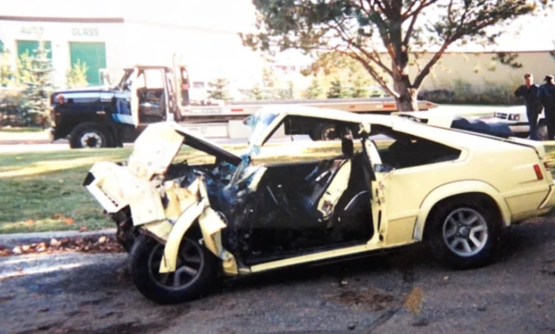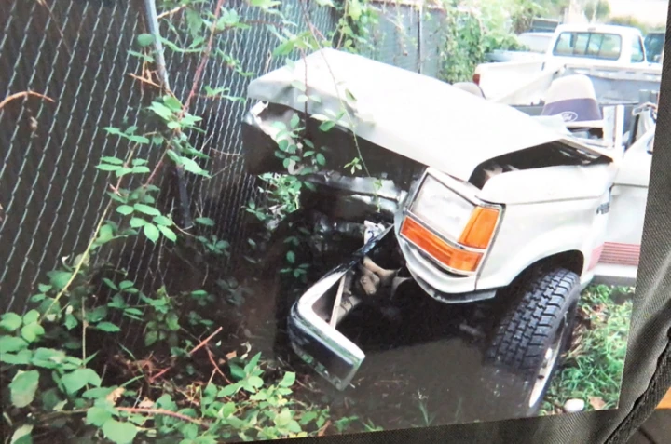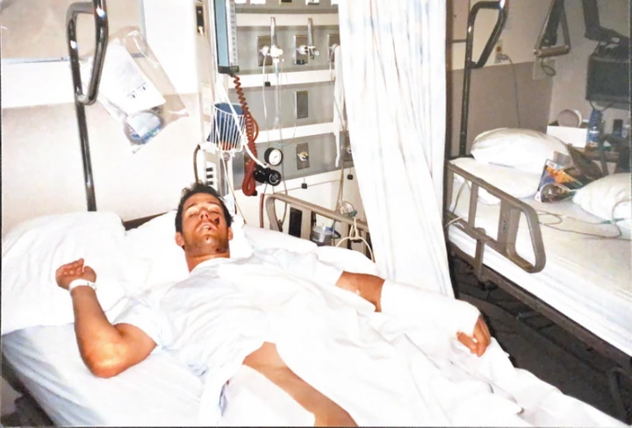

Grip strength — a hidden key to health and power
Grip strength is one of the heartbeats of arm wrestling. It’s the first point of contact, the bridge between your willpower and your opponent’s resistance. Before the referee even says “Ready… Go!”, the match has already begun in your hands.
What many people don’t realize is that grip strength goes far beyond arm wrestling. It’s a direct reflection of your overall health, endurance, and even longevity. Studies show that people with a stronger grip tend to live longer, have better cardiovascular health, and recover faster from injuries.
A strong grip means a strong body.
The human hand is a masterpiece of engineering — 27 bones, countless muscles, ligaments, and nerves all working in harmony. Every pull, twist, and hold activates a chain reaction through the wrist, forearm, elbow, shoulder, the back and even the legs.
Over the years, I’ve collected hand strengthening tools that are not fancy but portable, and incredibly effective.
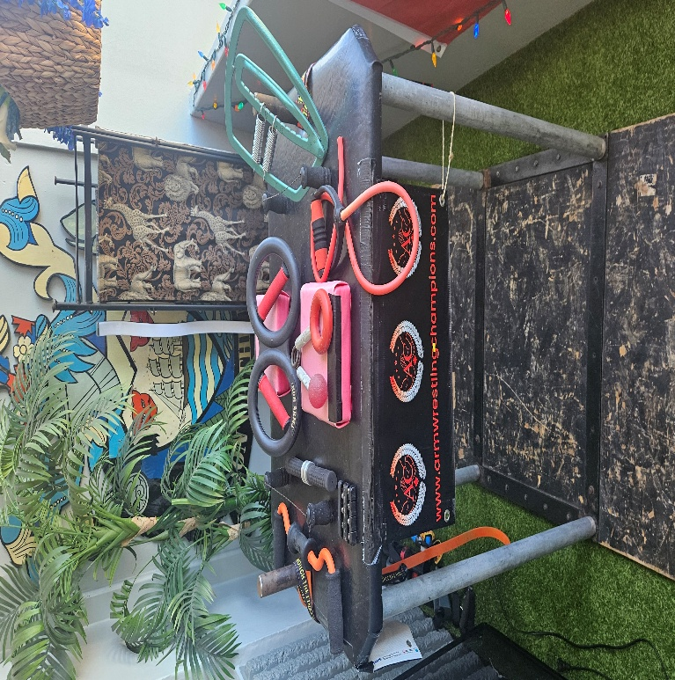

Here is a picture of my hand strength training
tools on my armwrestling table:

From left to right, the name of these tools are:
Forearms tool with orange levers
Grip master, (small and black for individual fingers)
Forearms tool to work the wrist rotation (12” long
with black handles)
On the far elbow pad - iron arms wrist rotation tool (with
red handles) for pronation and supination, this tool can be
flipped to reverse the tension
On the near elbow pad 3 things – 1 captains of crush
silver hand grippers (these come in different levels),
2 small round squeeze ball, 3 red round grip pro trainer.

Many of these tools can be carried in your pocket while walking or jogging
4 feet long stretchy band with hand gripper on the end – this can be tied to any stable thing, put in a door frame or stepped on to hold
Evanko green hand grip tool – springs are adjustable to change resistance

I also use a bucket of rice – insert my hand and squeeze my fingers both in and out

I keep some of these tools in my car and use them while I am waiting for someone, I keep some at home by the couch that I use while watching TV, and some in my gym bag if I am waiting for someone.
You never know when you’ll have spare time to do a few repetitions. The secret is consistency — not intensity. A few minutes every day adds up to thousands of micro-repetitions that compounds over time.

Grip as a Health Indicator
grip strength tells you a lot about your health. When I feel a strong grip, I can often tell who’s eating well, who’s sleeping enough, and who’s under stress. A weak grip doesn’t just mean weak muscles — it can indicate stress, overtraining and dehydration. I always recommend that all people train their grip strength.
If there’s one thing to remember about grip strength, it’s this: strength starts in your hands, but it grows from your heart. Grip is not just a skill — it’s a symbol of perseverance.

Good sportsmanship and team spirit — the soul of the sport
Armwrestling isn’t just about who wins and who loses — it’s about how you play. True champions understand that respect and sportsmanship are just as important as trophies.
When I am at an armwrestling tournament, most of the people there are my friends. When the call my name to compete against someone, they go from friend and become an enemy.
After the match, they are my friend again.
When I walk into a tournament, I see people who know the hours of training, the sacrifices, the pain. There’s a mutual respect that transcends competition.
Before a match, I always shake hands with my opponent and wish them luck. This is required in some tournaments, but not all.
It doesn’t make me weak — it makes me centered. Whether I win or lose, I always try to say, “Good match.” That simple gesture builds trust and camaraderie that lasts beyond the event.

Turning Rivals into Mentors
Some of the greatest lessons I’ve learned came from people who beat me. Instead of seeing them as enemies, I saw them as teachers. Every time I lost, I’d ask, “What did they do better? How can I learn from that?” That attitude transformed my career.
That kind of courage defines what this sport is all about — resilience, bravery, and respect for the game.

The Role of Humility
Winning humbly is just as important as losing gracefully. I’ve seen many athletes lose the respect of their peers because they celebrated without class or blamed others for their losses. Armwrestling teaches humility — because the moment you think you’re unbeatable, someone will prove you wrong.
At every tournament, I remind myself: “Lower the stakes, not the standards.” Play fair, support others, respect the referees and celebrate others’ victories as much as your own.

Strategic Sportsmanship
Good sportsmanship doesn’t mean being naive. It’s possible to be smart, respectful and strategic. When setting up at the table, I stay relaxed, give the impression of being easygoing and not caring — what my peers call “the master of misconception.” While staying calm, I’m studying my opponent, waiting for that perfect moment to strike.

Team and legacy
I’m proud to be part of one of the best armwrestling teams in Canada, the Vancouver Armwrestling Club. I counted the number of people at the club one Sunday and there were 45 people there. Four of our members have won the John Miazdzuk award including Dave Hicks, Anthony Dall’Antonia, Patrick Callen and Clayton Faulconer. This award is one of the greatest achievements and honors in Canadian arm wrestling. John Miazdzuk was the heart and soul of our sport. His passion built a community that continues to grow today.
When we compete, we don’t just represent ourselves — we represent a legacy. I want every armwrestler that I train with to compete with integrity, to build others up, and to make the sport better than they found it.

Staying lean, fit, and focused
Competitive armwrestling is not just a sport of strength, it’s a lifestyle of discipline. Staying in shape, maintaining weight, and keeping endurance high are essential for long-term success.

Morning walks and consistency
Five days a week, I wake up early, have a cup of coffee (no cream or sugar), and walk or jog before eating. Even when it’s raining or snowing and in Vancouver, that’s often — I go anyway.
There’s something powerful about starting your day by overcoming resistance, even in the smallest way.
One morning, I walked 3.85 km through freezing rain. My feet were soaked, my hands numb, but my mind was on fire. I knew that every step was strengthening not just my body, but my discipline.
I carry a hand-grip tool in my pocket and use it while I walk to strengthen my hands. I am doing two things at once, burning calories and strengthening my hands.
The hardest part is always starting — once you begin, the body follows the mind.

Weight class awareness
For armwrestlers, being in the lowest weight class is a good strategy. Staying lean allows you to compete against athletes of similar size but with potentially less conditioning. My goal is always to compete at the top of my weight class in the lightest division.
Maintaining weight doesn’t mean starving yourself, it means making smart choices. I avoid processed foods, high fat, carbohydrates and sugar foods. I drink a lot of water and hydrate consistently. I eat balanced meals that fuel performance, not cravings.

Training sincerity
What separates good armwrestlers from great ones is sincerity and doing the work when no one’s watching. Staying lean is more than looking good; it’s about being fit and ready.
Fitness should not be a phase, but should be a way of life. I train because I love the sport I have chosen and also because it makes me feel younger, alive, focused, and grounded.

The importance of sleep and recovery
Good sleep is a silent pillar of performance. You can train often, eat well, and supplement perfectly, but without quality rest, your progress stalls. Clayton learned this lesson the hard way during his years working graveyard shifts. The constant fatigue, irritability, and low recovery made me realize that sleep isn’t optional — it’s foundational.

Build a healthy sleep routine:
Aim for a minimum of 6 hours of sleep every night. I keep my room cool, dark, and quiet. My phone stays off, my mind stays calm, and I focus on relaxation. Use a comfortable mattress, a supportive pillow, and having a consistent bedtime make all the difference.
Avoid eating right before you sleep, and stay away from alcohol, which can disrupt a deep sleep. If you can’t sleep, use melatonin to assist.
Armwrestling is a sport that pushes fatigue. Without proper recovery, your muscles, tendons, ligaments, and nervous system can’t heal. That’s why I treat sleep as seriously as training. Every hour of rest is an investment in tomorrow’s performance.

Knowing when to rest and when to push forward
Injuries are part of every sport competitors story. Over the last 2 years, Clayton has torn his upper bicep, the front and back of his shoulder, his forearm and had many had other injuries to other muscles and tendons. Many people recommended that I stop armwrestling, but I refuse to stop.
I have pushed through more pain than what any person should, but each setback taught me something crucial: this pain is “good pain” caused from exercising and “bad pain” is caused from a pull or tear injury.
Clayton believes that good pain is positive and bad pain in negative and challenging.
I studied what caused the injuries and improved my form to prevent dangerous positions and more injuries. One key is knowing when to stop and when to keep going. Pushing through good pain can build toughness, but ignoring it can lead to bad pain and can end careers or competitions. The art of longevity lies in listening to your body.
The satisfaction is in victory and there are lessons in every loss. If you ever feel like quitting, remind yourself why you started. Your purpose will carry you further than any muscle ever could.

The top secrets to winning armwrestling matches
Every competitor has their principles. These are mine—the six rules I live by on and off the armwrestling table:

- Practice relentlessly
There’s no substitute for repetition. The more you practice, the more instinctive your movements become. Every hour at the table refines your timing, balance, and reflexes.

- Study your opponents
Observation is power. Watch their technique, posture, and preferred moves. Know how they win — and prepare to counter it.

- Master the winning moves
The foundation of a great arm wrestler lies in these techniques:
- Top-roll (for leverage)
- Hook (for control)
- Cupping with side pressure (for domination)
- Dragging straight down (for surprise finishes)
- How to win in the hand straps (when the hands come apart)

- Be strategic with fouls
Sometimes taking a foul can help you.
If you want to win: at the beginning of a match, starting early and quickly is a great way to see how your opponent will move. You will get a warning for starting early, but they will also see how your competitor will move which he will not be able to control due to instinctive reflex. This will be their strongest move.
The referees may stop the match due to this or you may have to win. To be strategic, if the match is stopped, on the next start do the opposite of what your competitor did the first time. I call this exposing your opponents’ weakness.
If you are losing, you can move your elbow off the pad. You must do this quickly (within 45 degrees from center) and not in a losing position or it is a loss. If you elbow foul in a non losing position, the match may be stopped and will give you a second chance to get control. It’s slightly risky, but if you know you are losing, it is a great way to prevent a loss. On the next start, you can be faster to try and gain control of the match.

- Perfect your positioning
Body mechanics are a major component of winning. Ensure that you:
keep your shoulder where it is the best help. If you have a push style, keep your shoulder behind your hand.
If you have a pull style, keep your shoulder closer to the pin pad then your hand.
Stay as high as possible. Do not be embarrassed for using a riser platform that will give you 4” of height. They do take practice to use to their fullest potential.
Always keep your hips close to the table and move them in the direction you want to move – side to side and up and down. Power in any strength sport comes from the hips
use your entire body, lock your arm in a stable position and all muscles including your core, back and legs and hips.

- How to win in the hand straps
When the hands come apart during an armwrestling match, the hand straps are put on. When the straps are used different muscles are used than a match without the hand straps. I recommend using the straps in every training session because you will develop the muscles required when using hand straps over time.

Conclusion
Arm wrestling has been my greatest teacher. It’s shown me the meaning of discipline, the value of patience, and the beauty of resilience.
From my first loss to my greatest wins, from injuries to near-death experiences, this sport has shaped who I am. It’s given me friendships, stories, lessons, and a reason to wake up every day with purpose.
If you’ve made it this far, you already share that spark — the desire to grow, to improve, to challenge yourself. My message to you is simple: never stop armwrestling.
Keep training, keep learning and keep believing. Strength isn’t built in the gym — it’s built in the moments you refuse to give up and make decisions to move forward.

Written by Clayton - Armwrestling Coach | Personal Trainer

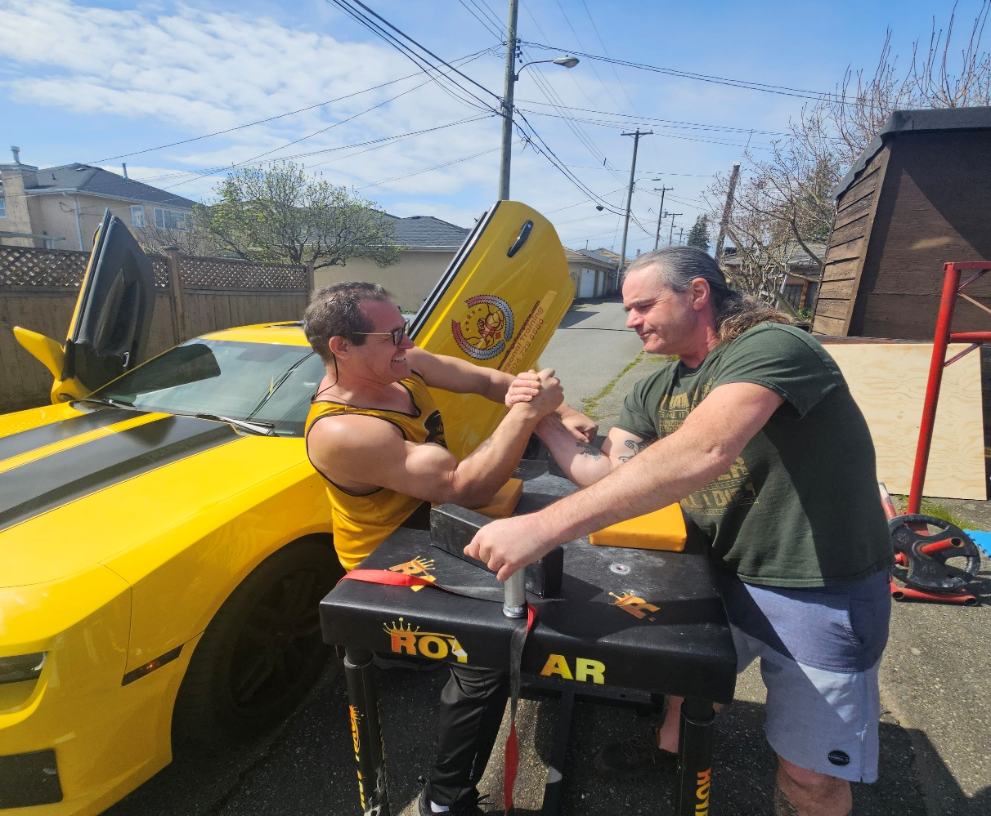


About the Author

Clayton Faulconer is a Canadian armwrestling champion with over 30 years of
competitive experience. He has competed nationally and internationally, coached
hundreds of athletes, and continues to dedicate his life to educating and promoting the

arm
armwrestling community.

About the Producer

Rick D. Belantes is the founder and project leader of Digital Core Media Marketing,
specializing in digital strategy, branding, and business development across North
America. He partners with entrepreneurs and creators to bring powerful stories and
impactful content to life.
www.digitalcoremediamarketing.co
m

WWW.CLAYTONFAULCONER.COM

